Our Neighbour

Severn Trent
PO Box 407
Darlington
DL1 9WD

January 2025

Please keep this letter handy until the work is complete

Dear Neighbour

We’re making improvements that may affect you in Diddlebury, Craven Arms

We’re investing £404,000 on improving our Borehole Pumping Station, The Moors, Diddlebury. A new pipeline will be installed within the adjoining field, running from the treatment works to the local water course, which runs alongside Mill Lane. This pipeline will enable us to discharge water from the treatment works into the local brook prior to our treatment and distribution processes. Along side the brook a structure will be built to protect the bank to the watercourse. Please see map below.

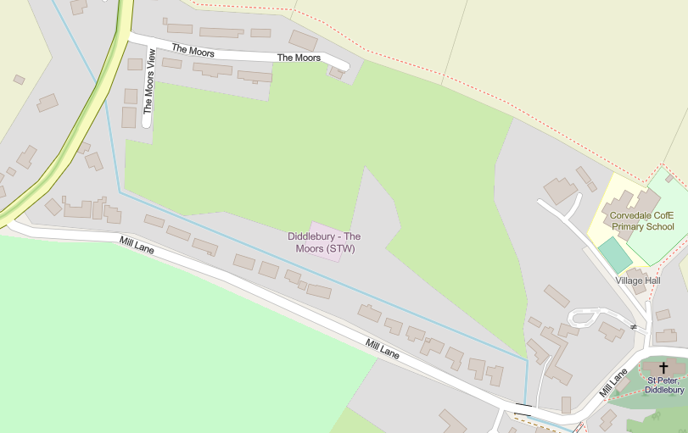
Finish
Start

The works will start on Monday 27 January 2025 and will be completed by mid April 2025. Please be aware that although we try to stick to these dates, they may change due to circumstances beyond our control.

During this work you will see an increase of large vehicles entering and exiting the site. We’re really sorry about any noise or nuisance we cause during this essential work, the teams will be working as quickly as possible to complete this work.

Who do I contact about the work?
- If you have any queries about this work, please get in touch with me on 07971 304604 between 8am and 5pm Monday-Friday.
- If you experience any issues with your water or sewerage service while the work is being done, please call our 24 hr operations centre on 0800 783 4444.

Yours faithfully

Catherine Webb
Community Communications
Severn Trent

